
UNIVERSITY OF LAY ADVENTIST OF KIGALI (UNILAK)

RWAMAGANA CAMPUS
P.O.BOX 6392 KIGALI, Phone: +250731743430/+250731743431
Email: info@unilak.ac.rw; Website: www.unilak.ac.rw
FACULTY OF COMPUTING AND INFORMATION SCIENCES
MASTER OF SCIENCE IN INFORMATION TECHNOLOGY (MIT)
ACADEMIC YEAR: 2025-2026

PROJECT: CITIZEN ISSUES REPORTING AND ESCALATION SYSTEM

NAME: NKURUNZIZA James
REG NUMBER: M05233/2026

Lecturer: Mr. Ignace HAKIZIMANA

20th June 2026

Introduction
The Citizen Issues Reporting and Escalation System (CIRES) is a digital platform designed to improve communication between citizens and service providers by enabling the reporting, tracking, and resolution of public concerns and service delivery issues(Johnson et al., 2020). The system provides a structured mechanism through which citizens can submit complaints, feedback, and requests, while ensuring that unresolved issues are escalated to the appropriate authorities for timely action. CIRES promotes transparency, accountability, and responsiveness in governance by strengthening citizen participation and improving the efficiency of issue management processes(Famularo, 2023). Through real-time monitoring and reporting, the system supports better decision-making and enhances public trust in institutions (Famularo, 2023).

Abstract
The Citizen Issues Reporting and Escalation System (CIRES) is a web-based platform designed to facilitate effective communication between citizens and public service institutions by providing a centralized mechanism for reporting, tracking, and resolving community issues (Junaidi et al., 2024). The system addresses challenges associated with traditional complaint management processes, such as delayed responses, lack of transparency, and poor accountability (Sun & Cai, 2017).
CIRES enables citizens to submit complaints, suggestions, and service requests through an easy-to-use interface. Reported issues are categorized and routed to the responsible authorities for action. The system incorporates an escalation mechanism that automatically forwards unresolved cases to higher levels of management, ensuring timely intervention and resolution. Additionally, users can monitor the status of their submissions in real time and receive feedback throughout the resolution process (Johnson et al., 2020).
The project aims to improve service delivery, strengthen citizen engagement, enhance transparency, and promote accountability within public institutions. By leveraging information technology, CIRES contributes to more responsive governance and efficient management of citizen concerns, ultimately fostering trust between citizens and service providers (Famularo, 2023).

Executive Summary
The Citizen Issue Reporting & Escalation System (CIRES) is a configurable, multi-module digital platform designed to digitize public service issue reporting, with a specific focus on strict geographic escalation and SLA-based (Service Level Agreement) accountability (Toker et al., 2025). The system provides an end-to-end view of citizen complaints—from initial reporting at the village level, to automated escalation through the administrative hierarchy, to final resolution and citizen feedback (Rahim & Omar, 2017).
CIRES replaces fragmented, manual, and opaque processes that currently lead to data inconsistencies, delayed problem resolutions, and limited accountability (Omelianenko, 2025). By digitizing these workflows using a strictly normalized 5-level geographic database, the system enables local and national government bodies to build trust among citizens, meet modern service delivery requirements, and operate efficiently. The initial rollout targets administrative sectors within Rwanda, with an architecture designed to scale seamlessly (C, 2025).
Project Background and Context
Citizens and local government leaders require a standardized, transparent, and auditable system to manage the reporting and resolution of public infrastructure and social issues. Currently, complaint tracking and resolution records are often handled manually using paper forms, logbooks, and informal communication channels. These methods are slow, error-prone, difficult to audit, and frequently lead to disputes over response times and accountability (Junaidi et al., 2024).
By strictly normalizing Rwanda’s geographic structure (Province → District → Sector → Cell → Village) into the database, CIRES eliminates data entry errors and ensures that every reported issue is mathematically locked to a specific physical location. Automated SLA timers ensure that if a local leader fails to resolve an issue within the mandated timeframe, the system automatically routes the ticket to the next level of authority, guaranteeing eventual resolution (Sun & Cai, 2017).

Literature Review
The evolution of public administration has been significantly shaped by the integration of Information and Communication Technologies (ICT), moving toward what scholars define as e-Government. Research indicates that traditional methods of reporting civic issues such as physical visits to local offices or manual paper-based filing (Famularo, 2023)suffer from high latency, lack of transparency, and frequent data loss. According to contemporary studies in digital governance, the primary barrier to effective citizen-state interaction is not the lack of reporting, but the lack of a structured Escalation Matrix. Without an automated system to track a complaint from the initial filing to a resolved state, administrative accountability remains performative rather than functional (Sun & Cai, 2017).
Furthermore, the implementation of Role-Based Access Control (RBAC) and automated workflows in digital platforms has been identified as a critical factor in reducing corruption and bureaucratic bottlenecks. In many developing administrative frameworks, a "silo effect" occurs where information is trapped within a single department with no external oversight (Rahim & Omar, 2017). Literature suggests that systems providing real-time visibility to multiple administrative tiers similar to the architecture of CIRES creates a "digital trail." This trail ensures that if a local official fails to address a reported infrastructure or social issue within a predetermined timeframe, the system's logic triggers an upward escalation, thereby enforcing a hierarchical responsibility that manual systems cannot maintain.
Finally, the success of such systems depends heavily on the User Experience (UX) and the reliability of the underlying data structure. Academic discourse on "Citizen-Centric Design" emphasizes that for a reporting system to be effective, it must be accessible to users with varying levels of technical literacy while maintaining a robust backend. The use of modern frameworks like Spring Boot and relational databases (e.g., MariaDB) allows for the high data integrity required to store sensitive identifiers, such as the national Id (Omelianenko, 2025). By ensuring that the database schema is optimized for both quick retrieval and secure storage, digital governance platforms can move beyond simple data collection and become active tools for social accountability and automated public service management (C, 2025).

Project Objectives

1. Automation of Civic Reporting and Data Centralization
The primary objective of CIRES is to transition from archaic, paper-based complaint filing to a centralized digital submission portal. Traditional governance often suffers from "administrative amnesia," where physical records are lost, damaged, or trapped in local silos. By digitizing the entry point, the system ensures that every issue reported by a citizen is immediately converted into a permanent, searchable, and auditable data record. This centralization allows for a unified view of the state of public services, ensuring that no citizen's voice is silenced by a misplaced folder (R et al., 2025).

2. Enforcement of Accountability via SLA-Based Escalation
A critical vision of this project is to move beyond passive record-keeping and into active enforcement of duty. CIRES implements Service Level Agreement (SLA) countdown timers that attach a specific resolution window to every report. This objective introduces a "System-Led Accountability" model: if an assigned officer fails to act within the stipulated timeframe, the system triggers an automatic escalation to higher-ranking officials. This ensures that administrative responsibility is not a choice but a requirement, as the software creates a transparent trail of officer performance and responsiveness (Sardjono & Hakim, 2019).

3. Real-Time Transparency and Citizen Agency
CIRES aims to eliminate the "black hole" effect, where citizens submit grievances and never receive feedback on the progress. By providing a real-time tracking interface, the project grants citizens the agency to monitor their reports through various stages—from "Pending" and "Assigned" to "In-Progress" and "Resolved." This transparency serves as a digital bridge of trust between the government and the public. When citizens can see exactly which department is handling their issue, it reduces frustration and eliminates the need for repeated, time-consuming physical visits to government offices (Bendhi, 2025; Nurdiani et al., 2025).

4. Intelligent Routing and Operational Efficiency
To maximize the impact of government resources, CIRES focuses on the elimination of bureaucratic redundancy through intelligent routing. Instead of a general-purpose desk receiving all complaints, the system uses categorized logic to send issues directly to the relevant specialized department, such as Land, Utilities, or Security. This objective ensures that the right expert receives the right problem at the right time. By bypassing unnecessary middlemen, the system reduces the "ping-pong" effect of manual administration and significantly accelerates the speed of public service delivery (Guo & Zhang, 2014; Zhang, 2023).

5. Data-Driven Governance and Proactive Resource Allocation
Beyond fixing individual problems, the broader objective of CIRES is to serve as a diagnostic tool for leadership. By aggregating data on the types and locations of reported issues, the system identifies geographical or departmental "hotspots" of failure. This allows the government to shift from a reactive mode—fixing things only when they break—to a proactive, evidence-based strategy. If the system shows a high density of utility-related reports in a specific sector, high-level decision-makers can use that data to prioritize infrastructure budgets and long-term developmental planning for that specific region (Ghosh, 2024).

Scope of the Study

Technical Scope (System Features)
The project focuses on delivering a robust, web-based platform designed for transparency and automated accountability. The development will cover the following key functional areas:
- Multi-Tiered Administrative Architecture: Support for hierarchical governance levels (Village, Cell, Sector, District) with strict data visibility rules based on jurisdiction.
- User & Role Management: Configurable access control for Citizens, Local Officers, Department Heads, and Supervisors using secure authentication.
- Citizen Reporting Portal: A user-friendly interface for residents to submit issues with categorized metadata (e.g., Land, Security, Infrastructure) and support for evidence uploads.
- Automated Escalation Engine: A core logic module that tracks resolution timelines (SLAs) and automatically promotes unattended issues through six administrative levels.
- Intelligent Routing System: Backend logic that parses report categories to ensure grievances are instantly directed to the correct specialized department.
- Real-Time Status Tracking: A transparency module allowing citizens to monitor the "Life Cycle" of their report from submission to final resolution.
- Supervisor Dashboard & Analytics: Comprehensive data visualization tools for high-level officials to monitor departmental performance and regional "hotspots."
- Audit Trail & Accountability Log: A non-modifiable ledger that records every action taken on a report, including timestamps of officer comments and status changes.
Exclusions (Out of Scope):
- Native Mobile Application: The system will be optimized for mobile web browsers (Responsive Design) but will not include standalone iOS or Android apps for the MVP.
- Irembo Integration: Direct API syncing with the Irembo platform is reserved for future enterprise scaling.
- SMS Gateway Integration: Notifications will be handled via in-system alerts and email rather than cellular SMS.
- Offline Mode: The system requires an active internet connection for submission and tracking; offline data caching is currently out of scope.

Geographical Scope
The initial study and system deployment will target specific local government entities within Rwanda. The architecture is designed to align with the Rwandan administrative structure (Province to Village), ensuring the system is culturally and procedurally relevant to the local context before any planned national expansion.

Time Scope
The project implementation will strictly follow the Project Topic Proposal Submission: Friday, 05-June-2026, 4:00 PM. This commences with the Requirement Gathering and Database Design phase, moving through Development and Testing, and concluding with a Submission of Project report, and Postman Collection: Sunday, 21-June-2026, 8:00 Am and demonstrate the API Sunday, 21-June-2026, 8:00 Am

Target Users

1. Citizen
The Citizen is the primary end-user and initiator of the system workflow. Tasked with identifying and reporting civic grievances, this user utilizes the web portal to submit detailed descriptions and evidence (such as photos) of local issues. Their involvement is centered on "Active Oversight," as they have the unique ability to track the real-time progress of their reports, ensuring their concerns are not ignored by the administrative hierarchy.

2. Local Officer (First-Line Responder)
The Local Officer is the administrative actor responsible for the initial intake and resolution of reported issues at the grassroots level (Cell or Sector). This user is tasked with investigating the validity of reports, providing technical updates, and closing cases within the mandated timeframe. They are the primary subjects of the system’s accountability logic, as their responsiveness directly dictates whether an issue remains local or triggers an automated escalation.

3. Supervisor (High-Level Authority)
The Supervisor represents the oversight tier of the platform, typically occupied by District-level officials or Mayors. This user does not manage day-to-day reports but instead focuses on "Escalated Cases"—issues that have exceeded their resolution deadlines. Through a specialized dashboard, the Supervisor monitors departmental performance and intervenes in stagnant cases to ensure that lower-level officers are fulfilling their service obligations to the public.

4. System Administrator
The System Administrator is the technical custodian responsible for the platform's operational integrity. This user manages the "Rules of Engagement" within the system, including user role provisioning, security configurations, and the calibration of the 6-level escalation logic. Their primary focus is maintaining a secure and functional environment, ensuring that the software accurately reflects the current government administrative structure and role-based access policies.

User Stories
The following user stories define the functional requirements of the CIRES platform based on the key stakeholders identified.

1. As a Citizen (Initiator)
I can register an account using my nationalId, select a specific issue category (e.g., Land, Utilities, Security), upload supporting evidence, and submit a formal report. I can also track the real-time status and view the SLA countdown timer for my active cases.
- Acceptance Criteria (AC): The report is successfully saved in a "Pending" state, the correct department receives an immediate notification, and the citizen receives a unique tracking reference number.

2. As a Local Officer (Assignee/First-Line Responder)
I receive an automated notification when a new issue is routed to my jurisdiction. I can review the evidence, update the status to "In-Progress," provide feedback comments to the citizen, and mark the issue as "Resolved" once field actions are complete.
- AC: All status changes are timestamped and logged. If the task is not moved to "In-Progress" within the predefined SLA window, the system prepares the record for automatic escalation.

3. As a Supervisor (High-Level Authority)
I can access a specialized dashboard to view all escalated cases that have exceeded their local SLA. I can intervene by reassigning tasks, contacting negligent officers directly through the system, and reviewing regional performance analytics to identify administrative bottlenecks.
- AC: The dashboard identifies "Critical" delays in red, provides the full audit trail of the local officer's (in)action, and allows for high-level "Resolution Overrides" to close long-standing issues.

4. As a System Administrator
I can configure the 6-level escalation logic, manage user roles and permissions, and onboard new administrative entities (Sectors/Districts). I am responsible for generating system-wide reports on resolution rates and maintaining the security of the global audit trail.
- AC: Administrative changes to the escalation timers or user roles are applied instantly across the platform and are recorded in the immutable audit log for compliance.

5. As a Department Head (Specialized Actor)
I can filter and manage issues specifically routed to my technical domain (e.g., Infrastructure or Water). I can provide expert feedback that requires specialized knowledge and collaborate with Local Officers to ensure technical grievances are handled accurately.
- AC: The actor only sees reports tagged with their specific department category, ensuring data isolation and operational focus.

6. As a Citizen (Evaluator)
Once a report is marked as "Resolved" by an officer, I can access the portal to rate the quality of the service provided and provide a final "Closing" comment to confirm my satisfaction or request a reopening of the case.
- AC: The rating is linked to the assigned officer’s performance profile, and the case status only moves to "Closed-Final" after citizen acknowledgment or a 48-hour auto-close window.

7. As a Supervisor / System Auditor
I can generate comprehensive analytical reports in PDF or CSV formats showing total issues reported, average resolution times per department, and a list of officers with the highest escalation rates.
- AC: Reports support dynamic filtering by date, category, and administrative level (Village to District), providing a clear heatmap of governance performance.
Functional Requirements
The functional requirements define the specific behaviors, services, and biological logic the CIRES platform must exhibit to meet user needs.

FR1: Advanced Identity and Access Management (IAM)
- Secure Authentication: The system shall provide a robust login/logout mechanism using encrypted credentials.
- Granular Role-Based Access Control (RBAC): Using Spring Security, the system must enforce strict permission boundaries between Citizens, Local Officers, Supervisors, and Administrators.
- Identity Verification: Registration must require a unique nationalId to ensure accountability and prevent duplicate or fraudulent reporting.
- Profile Self-Service: Users shall have the ability to manage their contact metadata (Email/Phone) to ensure the reliable delivery of system-generated alerts.

FR2: Intelligent Issue Orchestration
- Automated Categorical Routing: The system must automatically parse report categories (e.g., Land, Infrastructure) and route them to the specific department queue based on the user's administrative location (Sector/Cell).
- Multi-Media Evidence Handling: The platform shall support the secure upload and storage of digital evidence (JPEG, PNG, PDF) to validate reported grievances.
- Administrative Hierarchy Mapping: Users must select their location using a four-tier cascading dropdown (District > Sector > Cell > Village) to ensure the record is anchored to the correct jurisdictional boundary.

FR3: Automated Escalation and SLA Engine
- Dynamic SLA Countdown: Upon report submission, the system must initiate a real-time countdown timer based on the specific Service Level Agreement assigned to that issue category.
- 6-Level Autonomous Escalation: If a report is not transitioned to "Resolved" within the SLA window, the backend logic must autonomously elevate the ticket to the next hierarchical authority without manual intervention.
- Lifecycle Status Tracking: The system shall maintain and display a transparent "State Machine" for every report (Pending → In-Progress → Resolved → Escalated → Closed).

FR4: Governance and Oversight Tools
- Policy Configuration: Administrators shall have the authority to modify SLA durations, update governance levels, and manage issue categories via a secure control panel.
- Performance Analytics Dashboard: Supervisors must have access to a data visualization suite showing resolution heatmaps, average response times, and "Red-Flagged" tickets approaching breach.
- Administrative Intervention: Authorized Managers must be able to manually reassign misrouted tickets or grant documented extensions for high-complexity cases.

FR5: Communication and Immutable Logging
- Triggered Notifications: The system must dispatch real-time in-app and email alerts to officers upon new assignments or approaching SLA deadlines.
- Immutable Audit Trail: The system shall maintain a non-modifiable log of every transaction, status change, and comment, capturing the "Who, What, and When" for every action to ensure total accountability.
Non-Functional Requirements
The non-functional requirements define the quality attributes, performance goals, and technical constraints of the system.

N1: Performance and Scalability
- Low Latency UI: The Supervisor Dashboard and Citizen Portal must load in under 2 seconds, even during peak concurrent usage.
- High Throughput: The Java backend must utilize connection pooling (HikariCP) to handle multiple simultaneous submissions and complex SLA calculations without performance degradation.

N2: Reliability and Data Integrity
- High Availability (HA): The MariaDB database must ensure consistent uptime; since CIRES is a critical governance tool, any downtime results in a failure of the automated escalation logic.
- ACID Compliance: All database transactions must follow ACID properties to ensure that status changes and audit logs are never partially saved or lost during a system crash.

N3: Security and Privacy
- Cryptographic Hashing: All user passwords must be protected using the BCrypt hashing algorithm.
- Resource Authorization: Access to sensitive API endpoints must be restricted at the method level using Spring Security’s @PreAuthorize annotations.
- Data Confidentiality: Citizen identifiers (like nationalId) and contact details must be masked or encrypted at rest, visible only to authorized administrative personnel.

N4: Maintainability and Architecture
- Modular Design Pattern: The application must follow the Controller-Service-Repository pattern, allowing for the independent update of business logic without affecting the UI or Database layers.
- Comprehensive Documentation: All code must be self-documenting with clear JavaDocs, and database migrations must be tracked to facilitate future feature expansions (like SMS integration).

N5: Usability and Accessibility
- Intuitive UX/UI: The interface must follow clean, citizen-centric design standards (inspired by Irembo) to accommodate users with varying levels of digital literacy.
- Contextual Feedback: The system must provide explicit, user-friendly success and error messaging (e.g., "Your report has been successfully escalated to the District Mayor").
- Responsive Design: The web application must be fully functional across desktop and mobile browsers to ensure accessibility for field-based citizens.

Use Case Diagram
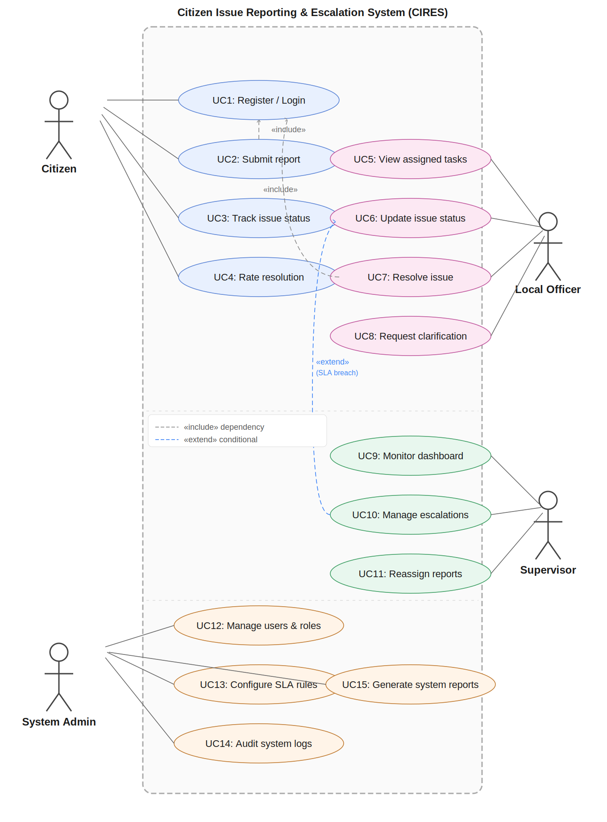

Admin Dashboard
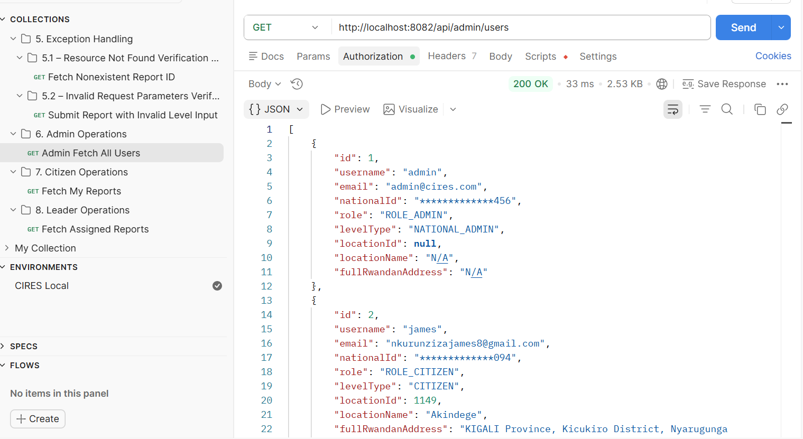

System Architecture(N-Tier)

Tier 1: Presentation Layer (Frontend Portals)
This layer is responsible for the user interface and the delivery of a responsive experience across different devices.
- Technologies: Database: MySQL, Backend: Java, Spring Framework, and Spring Boot, API Documentation: OpenAPI (Swagger), API Testing: Postman
- Functionality: Each actor (Citizen, Officer, Supervisor, and Admin) accesses a dedicated portal tailored to their specific use cases, such as report submission or performance monitoring.
- Dynamic Features: Handles real-time UI updates, including the SLA countdown timers and interactive location selection (Village to District).

Tier 2: API Gateway & Security Layer (Orchestration)
Acting as the entry point for the backend, this tier ensures that only authorized requests reach the business logic.
- API Gateway: Manages RESTful API request routing and load balancing between the frontend and microservices.
- Security Logic: Implements Spring Security with Role-Based Access Control (RBAC) to verify user identities (using National ID) and permissions before any data is processed.

Tier 3: Application & Business Logic Layer (Microservices)
This is the "brain" of the system where the core CIRES functional requirements are executed.
- Framework: Powered by Spring Boot and Jakarta EE to provide a robust, modular environment.
- Escalation Engine: A specialized module that monitors report timestamps and triggers the 6-level autonomous escalation logic when SLAs are breached.
- Service Modules: Contains independent services for Issue Management, Jurisdiction Routing, and Analytics Generation.

Tier 4: Data Persistence Layer (Database)
The foundation of the system, responsible for the reliable storage and retrieval of all governance data.
- Relational Database: MariaDB is used to maintain structured records for citizens, reports, and the immutable audit trail.
- ORM Layer: Uses Hibernate/JPA to map Java entities (like the Report and User classes) to the database tables, ensuring data integrity and efficient querying.

Tier 5: External Integration & Storage Layer
A dedicated tier for handling unstructured data and future external communications.
- File Storage: A separate storage unit for binary data, such as images/evidence uploaded by citizens and system-generated PDF reports.
- Notification Integration: (Future Scope) Provisions for integrating with SMS Gateways or email servers to dispatch real-time alerts.
Note that CIRES platform utilizes an N-Tier Architecture to ensure high availability, modularity, and a clear separation between user interaction, security, business logic, and data storage.

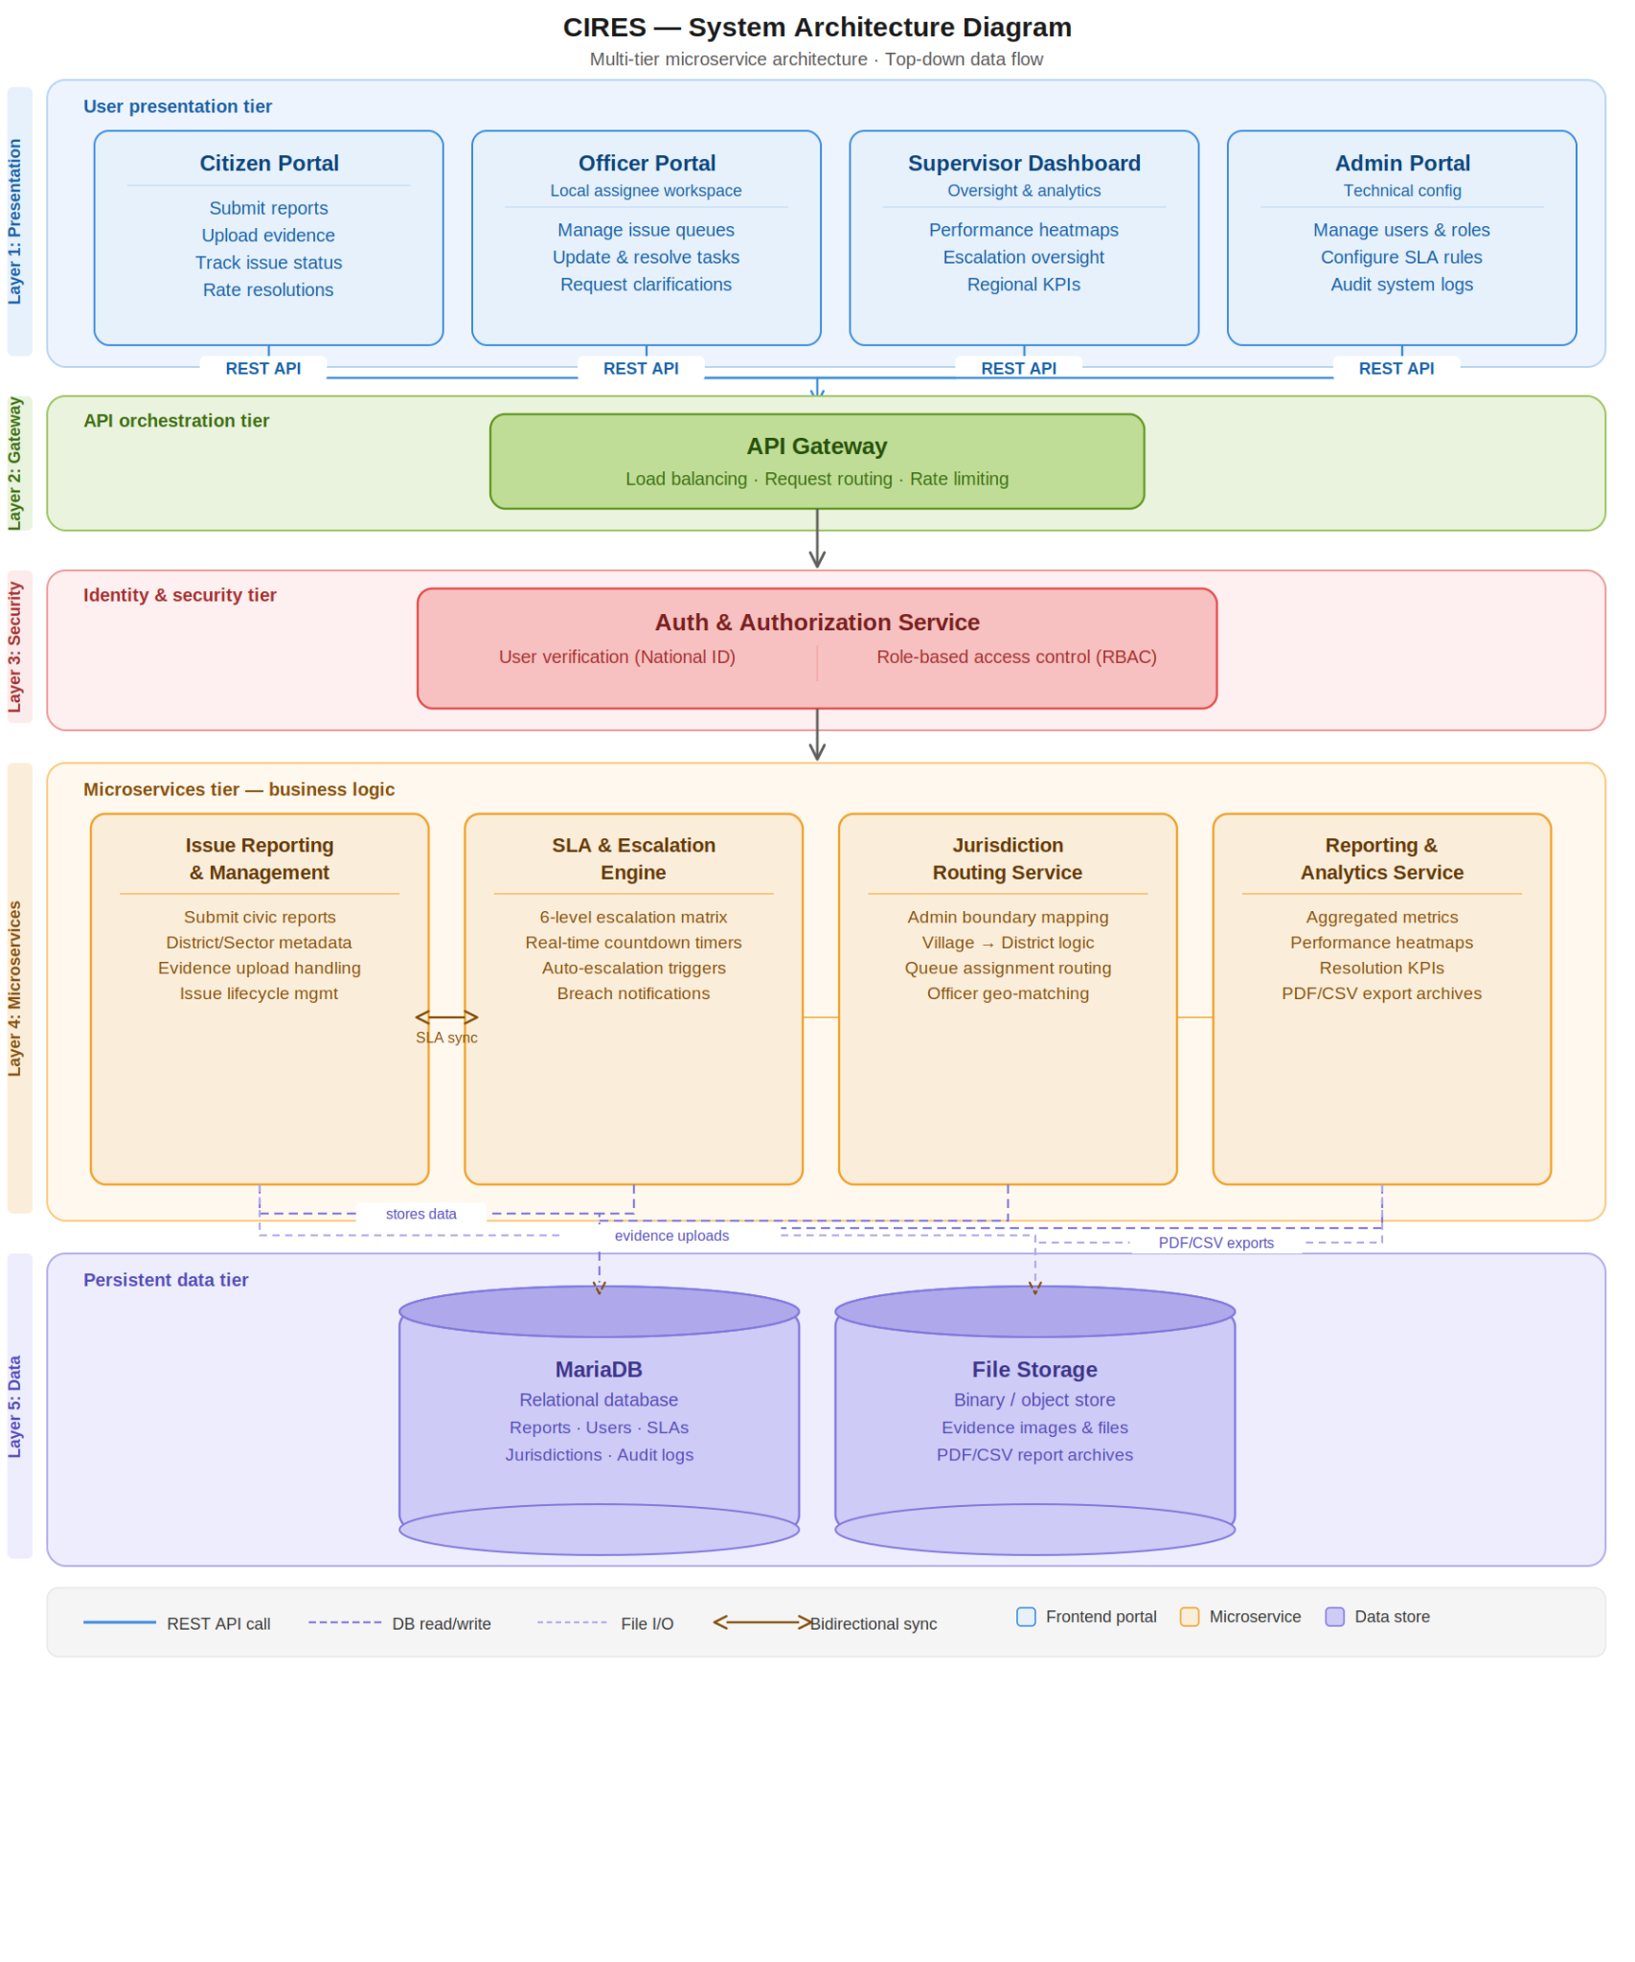

Authentication & Security

1. Overview
The Citizen Issue Reporting & Escalation System (CIRES) employs a robust, stateless security architecture to protect sensitive user data, government workflows, and geographic metadata. Built on Spring Security 6, the system utilizes JSON Web Tokens (JWT) for authentication and Role-Based Access Control (RBAC) for authorization. This ensures that citizens, local leaders, and administrators can only access and modify data within their authorized operational scope.

2. Security Model Explanation
The CIRES security model is designed to be highly scalable, decoupled, and secure against common web vulnerabilities.
- Stateless Session Management: The backend does not store HTTP sessions. Instead, every request from the frontend or mobile client must be independently authenticated using a JWT provided in the Authorization header. This eliminates Cross-Site Request Forgery (CSRF) vulnerabilities and allows the API to scale easily.
- Password Cryptography: User passwords are never stored in plain text. The system utilizes the BCrypt hashing algorithm (PasswordEncoder) to cryptographically salt and hash passwords before they are saved to the database.
- CORS Configuration: Cross-Origin Resource Sharing (CORS) is explicitly configured to allow the frontend application to securely communicate with the REST API without being blocked by browser security policies.

3. JWT & Security Configuration
The JWT lifecycle is managed by two primary components in the backend architecture:
- JwtTokenProvider: Responsible for generating the token upon successful login. It cryptographically signs the token using a secure, environment-injected secret key. The token payload (claims) includes the user's username, their assigned role, and a strict expiration timestamp to limit the window of potential token misuse.
- JwtAuthenticationFilter: A custom security filter that intercepts every incoming HTTP request. It extracts the Bearer token from the Authorization header, cryptographically verifies its signature and expiration, and extracts the user's details. If valid, it populates the Spring SecurityContextHolder, granting the user access to the requested resource.

4. Role-Based Access Control (RBAC)
Access to the CIRES API is strictly governed by the user's assigned role. The system defines a clear boundary between public data, citizen actions, and administrative duties.
Role | Access Scope & Permissions
UNAUTHENTICATED | Can only access public endpoints: /api/auth/register, /api/auth/login, and the geographic metadata endpoints (/api/address/**) needed to populate frontend dropdowns.
ROLE_CITIZEN | Can submit new issue reports, view their own reporting history (/api/reports/my-reports), and submit feedback on resolved issues.
ROLE_LEADER | (Includes Village, Cell, Sector, District, and Province Leaders). Can view tickets assigned to their specific escalation level, resolve tickets, and escalate tickets to the next tier of government.
ROLE_ADMIN | Has unrestricted access to system configurations. Can view all users, update user roles, and modify SLA configuration timers.
Note: Endpoint-level security is enforced using Spring's method security annotations (e.g., @PreAuthorize("hasRole('LEADER') or hasRole('ADMIN')")), ensuring that even if a citizen discovers an administrative URL, the server will reject the request with a 403 Forbidden status.

5. Authentication Flows
The AuthController handles the entry points for system access:
1. Registration Flow (POST /api/auth/register)
- The system accepts a payload containing the user's username, email, nationalId, and plain-text password.
- The backend validates that the username, email, and National ID are completely unique across the database.
- The password is encrypted via BCrypt.
- The user is saved to the database and automatically assigned the default CITIZEN role.
- Note: Elevated roles (like LEADER) cannot be self-assigned during registration; they must be granted by a System Admin.
2. Login Flow (POST /api/auth/login)
- The user submits their username and password.
- The AuthenticationManager securely compares the provided credentials against the BCrypt hash stored in the database via the CustomUserDetailsService.
- Upon successful verification, the JwtTokenProvider generates a signed JWT.
- The API returns an AuthResponse object containing the JWT, username, email, national ID, and role, which the frontend client stores securely to authorize subsequent API calls.

Entity Relationship Diagram
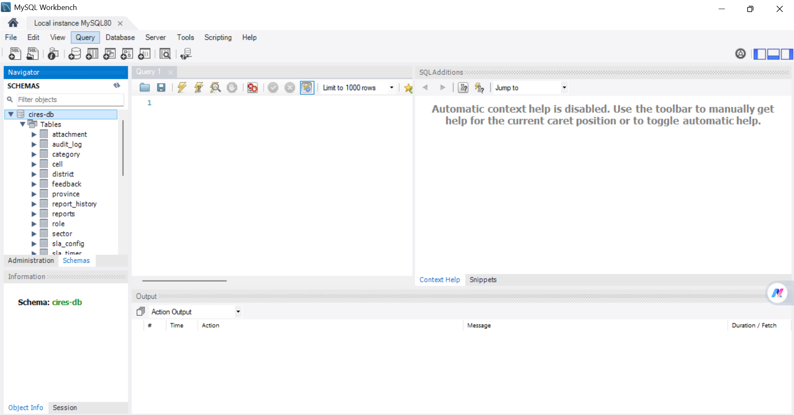

ERD for CIRES: https://dbdiagram.io/d/69cff7d80f7c9ef2c0764aef

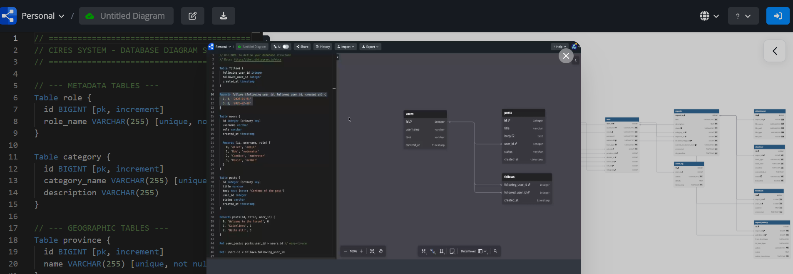

Geographic Entities

Table Name | Column Name | Data Type | Constraints | Description
province | id | BIGINT | PK, Auto | Unique identifier for the Province.
 | name | VARCHAR(255) | Unique, Not Null | Name of the Province (e.g., KIGALI).
district | id | BIGINT | PK, Auto | Unique identifier for the District.
 | name | VARCHAR(255) | Not Null | Name of the District.
 | province_id | BIGINT | FK, Not Null | Links to the Province table.
sector | id | BIGINT | PK, Auto | Unique identifier for the Sector.
 | district_id | BIGINT | FK, Not Null | Links to the District table.
cell | id | BIGINT | PK, Auto | Unique identifier for the Cell.
 | sector_id | BIGINT | FK, Not Null | Links to the Sector table.
village | id | BIGINT | PK, Auto | Unique identifier for the Village.
 | cell_id | BIGINT | FK, Not Null

Core Application Entities

Table Name | Column Name | Data Type | Constraints | Description
user | user_id | BIGINT | PK, Auto | Unique identifier for the user.
 | username | VARCHAR(255) | Unique, Not Null | User's login credential.
 | national_id | VARCHAR(16) | Unique, Not Null | Official identification number.
 | level_type | ENUM | Not Null | Defines hierarchy level (e.g., CITIZEN, VILLAGE_LEADER).
 | village_id | BIGINT | FK | Locks user to a specific geography.
reports | report_id | BIGINT | PK, Auto | Unique identifier for the issue.
 | incident_village_id | BIGINT | FK, Not Null | The exact village where the issue occurred.
 | current_escalation_level | ENUM | Not Null | Status: AT_VILLAGE, AT_CELL, AT_SECTOR, etc.
 | status | VARCHAR(50) | Not Null | Defaults to 'PENDING'.
 | sla_deadline | TIMESTAMP | Not Null

System Access & Users
Table Name | Column Name | Data Type | Constraints | Description
role | id | BIGINT | PK, Auto | Unique identifier for system roles.
 | role_name | VARCHAR(255) | Unique, Not Null | Name of the role (e.g., CITIZEN, ADMIN).
user | user_id | BIGINT | PK, Auto | Unique identifier for the user.
 | username | VARCHAR(255) | Unique, Not Null | User's login credential.
 | email | VARCHAR(255) | Unique, Not Null | User's email address.
 | password | VARCHAR(255) | Not Null | Bcrypt hashed password.
 | nationalId | VARCHAR(16) | Unique, Not Null | Official National Identification number.
 | level_type | ENUM | Not Null | Defines hierarchy level (e.g., VILLAGE_LEADER).
 | role_id | BIGINT | FK, Not Null | Links to the Role table.
 | province_id | BIGINT | FK (Nullable) | Locational tie for Province Governors.
 | district_id | BIGINT | FK (Nullable) | Locational tie for District Mayors.
 | sector_id | BIGINT | FK (Nullable) | Locational tie for Sector Leaders.
 | cell_id | BIGINT | FK (Nullable) | Locational tie for Cell Leaders.
 | village_id | BIGINT | FK (Nullable)

Core Issue Reporting
Table Name | Column Name | Data Type | Constraints | Description
category | id | BIGINT | PK, Auto | Unique identifier for issue categories.
 | category_name | VARCHAR(255) | Unique, Not Null | Category name (e.g., Water, Roads).
 | description | VARCHAR(255) | Nullable | Brief explanation of the category.
reports | report_id | BIGINT | PK, Auto | Unique identifier for the reported issue.
 | title | VARCHAR(255) | Not Null | Brief title of the public issue.
 | description | TEXT | Not Null | Detailed explanation of the issue.
 | status | ENUM | Not Null | Current state (PENDING, IN_PROGRESS, RESOLVED).
 | category_id | BIGINT | FK, Not Null | Links to the Category table.
 | reporter_id | BIGINT | FK, Not Null | Links to the User who filed the report.
 | incident_village_id | BIGINT | FK, Not Null | The exact village where the issue occurred.
 | current_escalation_level | ENUM | Not Null | Escalation status (e.g., AT_VILLAGE, AT_CELL).
 | created_at | TIMESTAMP | Not Null | System timestamp of issue creation.
 | sla_deadline | TIMESTAMP | Not Null | Calculated limit for current level resolution.
attachment | id | BIGINT | PK, Auto | Unique identifier for uploaded files.
 | report_id | BIGINT | FK, Not Null | The report this attachment belongs to.
 | file_name | VARCHAR(255) | Not Null | Name of the uploaded file/image.
 | file_path | VARCHAR(255) | Not Null | Storage path or URL.
 | file_type | VARCHAR(50) | Not Null | MIME type of the file.
 | file_size | BIGINT | Not Null

Escalation Engine & SLA Management
Table Name | Column Name | Data Type | Constraints | Description
sla_config | id | BIGINT | PK, Auto | Unique SLA rule identifier.
 | category_id | BIGINT | FK, Not Null | The issue category the SLA applies to.
 | level_type | ENUM | Not Null | Government level the SLA applies to.
 | duration_hours | INT | Not Null | Allowed resolution time in hours.
sla_timer | id | BIGINT | PK, Auto | Unique identifier for the active SLA countdown.
 | report_id | BIGINT | FK, Not Null | Links to the report being timed.
 | level_type | ENUM | Not Null | The government level currently responsible.
 | start_time | TIMESTAMP | Not Null | When the timer started.
 | deadline | TIMESTAMP | Not Null | The exact SLA breach timestamp.
 | completed_at | TIMESTAMP | Nullable | When the ticket was successfully resolved.
 | status | ENUM | Not Null | Timer status (ACTIVE, COMPLETED, BREACHED).
 | breached | BOOLEAN | Not Null

Auditing & Interactions

Table Name | Column Name | Data Type | Constraints | Description
report_history | id | BIGINT | PK, Auto | Unique identifier for the history record.
 | report_id | BIGINT | FK, Not Null | Links to the report being modified.
 | acted_by_id | BIGINT | FK, Not Null | Links to the User performing the action.
 | from_level_type | ENUM | Nullable | Previous escalation state (for transfers).
 | to_level_type | ENUM | Nullable | New escalation state.
 | action | VARCHAR(255) | Not Null | Action taken (e.g., "ESCALATED", "RESOLVED").
 | notes | TEXT | Nullable | Optional justification by the officer.
 | action_timestamp | TIMESTAMP | Not Null | Exact time of the action.
feedback | id | BIGINT | PK, Auto | Unique identifier for citizen feedback.
 | report_id | BIGINT | FK, Not Null | Links to the resolved report.
 | user_id | BIGINT | FK, Not Null | Links to the citizen providing feedback.
 | content | TEXT | Not Null | The feedback text/comments.
 | created_at | TIMESTAMP | Not Null | Timestamp of feedback submission.
audit_log | id | BIGINT | PK, Auto | Unique identifier for system security logs.
 | user_id | BIGINT | FK (Nullable) | User performing the logged action.
 | action | VARCHAR(255) | Not Null | Description of the system event.
 | details | TEXT | Nullable | JSON or text specifics of the event.
 | timestamp | TIMESTAMP | Not Null | When the system event occur

SQL SCRIPT

1. Metadata Tables
CREATE TABLE role (id BIGINT AUTO_INCREMENT PRIMARY KEY, role_name VARCHAR(255) UNIQUE NOT NULL);
CREATE TABLE category (id BIGINT AUTO_INCREMENT PRIMARY KEY, category_name VARCHAR(255) UNIQUE NOT NULL, description VARCHAR(255));

2. Geographic Tables
CREATE TABLE province (id BIGINT AUTO_INCREMENT PRIMARY KEY, name VARCHAR(255) UNIQUE NOT NULL);
CREATE TABLE district (id BIGINT AUTO_INCREMENT PRIMARY KEY, name VARCHAR(255) NOT NULL, province_id BIGINT NOT NULL, FOREIGN KEY (province_id) REFERENCES province(id));
CREATE TABLE sector (id BIGINT AUTO_INCREMENT PRIMARY KEY, name VARCHAR(255) NOT NULL, district_id BIGINT NOT NULL, FOREIGN KEY (district_id) REFERENCES district(id));
CREATE TABLE cell (id BIGINT AUTO_INCREMENT PRIMARY KEY, name VARCHAR(255) NOT NULL, sector_id BIGINT NOT NULL, FOREIGN KEY (sector_id) REFERENCES sector(id));
CREATE TABLE village (id BIGINT AUTO_INCREMENT PRIMARY KEY, name VARCHAR(255) NOT NULL, cell_id BIGINT NOT NULL, FOREIGN KEY (cell_id) REFERENCES cell(id));

3. Core Users Table
CREATE TABLE user (
user_id BIGINT AUTO_INCREMENT PRIMARY KEY,
username VARCHAR(255) UNIQUE NOT NULL,
email VARCHAR(255) UNIQUE NOT NULL,
password VARCHAR(255) NOT NULL,
nationalId VARCHAR(16) UNIQUE NOT NULL,
level_type VARCHAR(50) NOT NULL,
role_id BIGINT NOT NULL,
province_id BIGINT, district_id BIGINT, sector_id BIGINT, cell_id BIGINT, village_id BIGINT,
FOREIGN KEY (role_id) REFERENCES role(id),
FOREIGN KEY (province_id) REFERENCES province(id),
FOREIGN KEY (district_id) REFERENCES district(id),
FOREIGN KEY (sector_id) REFERENCES sector(id),
FOREIGN KEY (cell_id) REFERENCES cell(id),
FOREIGN KEY (village_id) REFERENCES village(id)
);

4. Reporting & SLA Tables
CREATE TABLE reports (
report_id BIGINT AUTO_INCREMENT PRIMARY KEY,
title VARCHAR(255) NOT NULL,
description TEXT NOT NULL,
status VARCHAR(50) NOT NULL,
category_id BIGINT NOT NULL,
reporter_id BIGINT NOT NULL,
incident_village_id BIGINT NOT NULL,
current_escalation_level VARCHAR(50) NOT NULL,
created_at TIMESTAMP NOT NULL,
sla_deadline TIMESTAMP NOT NULL,
FOREIGN KEY (category_id) REFERENCES category(id),
FOREIGN KEY (reporter_id) REFERENCES user(user_id),
FOREIGN KEY (incident_village_id) REFERENCES village(id)
);

CREATE TABLE attachment (
id BIGINT AUTO_INCREMENT PRIMARY KEY,
report_id BIGINT NOT NULL,
file_name VARCHAR(255) NOT NULL,
file_path VARCHAR(255) NOT NULL,
file_type VARCHAR(50) NOT NULL,
file_size BIGINT NOT NULL,
FOREIGN KEY (report_id) REFERENCES reports(report_id)
);

CREATE TABLE sla_config (
id BIGINT AUTO_INCREMENT PRIMARY KEY,
category_id BIGINT NOT NULL,
level_type VARCHAR(50) NOT NULL,
duration_hours INT NOT NULL,
FOREIGN KEY (category_id) REFERENCES category(id)
);

CREATE TABLE sla_timer (
id BIGINT AUTO_INCREMENT PRIMARY KEY,
report_id BIGINT NOT NULL,
level_type VARCHAR(50) NOT NULL,
start_time TIMESTAMP NOT NULL,
deadline TIMESTAMP NOT NULL,
completed_at TIMESTAMP,
status VARCHAR(50) NOT NULL,
breached BOOLEAN NOT NULL,
FOREIGN KEY (report_id) REFERENCES reports(report_id)
);

5. Auditing & Interaction Tables
CREATE TABLE report_history (
id BIGINT AUTO_INCREMENT PRIMARY KEY,
report_id BIGINT NOT NULL,
acted_by_id BIGINT NOT NULL,
from_level_type VARCHAR(50),
to_level_type VARCHAR(50),
action VARCHAR(255) NOT NULL,
notes TEXT,
action_timestamp TIMESTAMP NOT NULL,
FOREIGN KEY (report_id) REFERENCES reports(report_id),
FOREIGN KEY (acted_by_id) REFERENCES user(user_id)
);

CREATE TABLE feedback (
id BIGINT AUTO_INCREMENT PRIMARY KEY,
report_id BIGINT NOT NULL,
user_id BIGINT NOT NULL,
content TEXT NOT NULL,
created_at TIMESTAMP NOT NULL,
FOREIGN KEY (report_id) REFERENCES reports(report_id),
FOREIGN KEY (user_id) REFERENCES user(user_id)
);

CREATE TABLE audit_log (
id BIGINT AUTO_INCREMENT PRIMARY KEY,
user_id BIGINT,
action VARCHAR(255) NOT NULL,
details TEXT,
timestamp TIMESTAMP NOT NULL,
FOREIGN KEY (user_id) REFERENCES user(user_id)
);

API Endpoint Architecture
All API endpoints are secured using stateless JWT authentication.

1.Authentication & User Management
Method | Endpoint | Authorization | Description
POST | /api/auth/register | NONE | Registers a new citizen and assigns default role.
POST | /api/auth/login | NONE | Authenticates user and returns Bearer JWT.
GET | /api/admin/users | ADMIN | Retrieves list of all registered users.
PUT | /api/admin/users/{id}/role | ADMIN | Upgrades a user to a Leader/Officer role.

2. Geographic Metadata (Dropdown Population)
Method | Endpoint | Authorization | Description
GET | /api/address/provinces | ANY | Fetches all top-level provinces.
GET | /api/address/provinces/{id}/districts | ANY | Fetches districts mapped to a specific province.
GET | /api/address/cells/{id}/villages | ANY | Fetches villages to finalize incident reporting location.

3. Issue Reporting & Escalation Engine
Method | Endpoint | Authorization | Description
POST | /api/reports | CITIZEN | Creates a new issue tied to a specific village.
GET | /api/reports/my-reports | CITIZEN | Retrieves all issues reported by the logged-in user.
GET | /api/reports/level/{level} | LEADER | Retrieves active issues at a specific escalation level.
PUT | /api/reports/{id}/resolve | LEADER / ADMIN | Marks a pending report as resolved.
PUT | /api/reports/{id}/escalate | SYSTEM / ADMIN | Forces a report to the next administrative level.

4. Interactions & Audit Logging
Method | Endpoint | Authorization | Description
POST | /api/interactions/reports/{id}/feedback | CITIZEN | Submits rating and comments on a resolved ticket.
GET | /api/interactions/reports/{id}/history | ANY | Retrieves the immutable audit trail of a report.

Advanced Features & Business Logic

1. Overview
The CIRES platform relies on a robust set of advanced backend rules to ensure data integrity, enforce government accountability, and provide a seamless user experience. By embedding strict business logic directly into the API and database layers, the system guarantees that all citizen reports follow the correct administrative procedures without manual intervention.

2. Automated Workflows (The Escalation Engine)
The core workflow of the CIRES system is the Dynamic Escalation Engine, which programmatically enforces Rwanda’s geographic chain of command.
- Business Rule: An issue cannot bypass levels of local government. It must be addressed sequentially.
- Implementation: The ReportService utilizes a strict, state-machine-like switch statement based on the currentEscalationLevel enumeration. When an authorized user or the SLA timer triggers an escalation, the workflow rigidly forces the ticket up the exact geographic hierarchy: AT_VILLAGE → AT_CELL → AT_SECTOR → AT_DISTRICT → AT_PROVINCE → AT_NATIONAL.

3. Advanced Backend Logic
The backend utilizes advanced Spring Boot components to handle complex data initialization and security.
- Intelligent Data Seeding: To construct the strictly normalized 5-level geographic database, the system features a custom DataSeeder. Upon application startup, it parses a flat, 14,000+ record JSON file (locations.json). Utilizing HashMap caching strategies, the algorithm intelligently identifies existing parent regions in memory, preventing duplicate database entries and perfectly mapping every village to its correct cell, sector, district, and province.
- Stateless Security: The backend implements a custom JwtTokenProvider and JwtAuthenticationFilter. This ensures that all API requests are authenticated statelessly via JSON Web Tokens, improving scalability and protecting against traditional session-based vulnerabilities.

4. Data Filtering & Contextual Access
The system dynamically filters data so users only interact with information relevant to their roles and locations.
- Cascading Geographic Filtering: To prevent user error during issue reporting, the AddressController provides cascading endpoints. Selecting a Province filters the next query to only show Districts within that Province (e.g., /api/address/provinces/{id}/districts), continuing down to the specific Village.
- Contextual Report Filtering: The ReportController filters data based on the authenticated user's JWT. Citizens calling /my-reports exclusively receive tickets tied to their specific reporter_id, while local leaders calling /level/{levelId} exclusively receive tickets matching their jurisdiction's current escalation state.

5. Data Validation & Implemented Business Rules
To maintain absolute data integrity, the system enforces the following constraints at the API level:
- Creation Validation: A citizen cannot submit a report without providing a valid categoryId and incidentLocationId. The system permanently locks the ticket to the specific incident_village_id where the event occurred.
- Role-Based Access Control (RBAC): Business logic dictates that citizens cannot resolve or escalate their own tickets. Endpoints dictating workflow changes are protected by @PreAuthorize("hasRole('LEADER') or hasRole('ADMIN')"), rejecting unauthorized manipulation attempts with a 403 Forbidden response.
- Immutable Auditing: The system enforces an unbroken chain of custody. Whenever a ticket changes status, is escalated, or is resolved, the InteractionService automatically generates an unalterable ReportHistory record, detailing who took the action, what the action was, and the exact timestamp.
- Service Level Agreement (SLA) Tracking: The system incorporates SlaConfig and SlaTimer entities. Business rules dictate that every category of issue (e.g., Water, Roads) has a specific resolution timeframe. The backend calculates a rigid sla_deadline upon ticket creation, serving as the benchmark for local leader performance evaluations.
Frontend Development & Integration
Backend Connectivity: Spring Boot REST API (JWT Secured)
This document outlines the architecture, implementation, and integration of the client-side application for the Citizen Issue Reporting & Escalation System (CIRES). It details the transition from static UI components to a dynamic, fully integrated application layer consuming Java Spring Boot microservices.
Phase Overview
The primary objective of Phase 9 was to transform the standalone CIRES UI components into a fully functional, state-driven frontend application communicating securely with the Spring Boot backend.
Key Accomplishments:
- Established a robust N-Tier frontend architecture using React and TypeScript.
- Implemented secure JWT-based authentication and Role-Based Access Control (RBAC).
- Developed complex, data-driven user flows, including cascading geographical dropdowns and SLA-aware reporting logic.
- Successfully integrated all distinct user portals (Citizen, Leader, Admin) with live REST API endpoints.
Importance of Integration:
This phase bridges the gap between the user and the database. By integrating the frontend with the secured backend, CIRES transitions from a prototype to a real-world digital governance platform capable of processing actual citizen data securely.

3. Frontend Architecture
The frontend follows a modular, component-based N-Tier architecture designed for scalability and maintainability. The Vite build tool ensures rapid hot-module replacement and optimized production builds.
Folder Structure Overview:
- src/assets/: Static resources (images, global CSS).
- src/components/: Reusable UI elements (common/ for buttons/inputs, layout/ for navbars/sidebars).
- src/contexts/: React Context providers for global state (e.g., AuthContext).
- src/pages/: Page-level components organized by role (public/, citizen/, leader/, admin/).
- src/routes/: Routing logic and route protection components.
- src/services/: API integration layer (Axios instances and API call definitions).
- src/types/: TypeScript interfaces representing backend DTOs and entities.
State Management & Routing:
The application utilizes the React Context API to manage lightweight global state, specifically the user session and authentication status. Routing is handled by react-router-dom, employing a Protected Route wrapper to enforce role-based access before rendering sensitive components.

Authentication & Authorization
Security is enforced on the frontend by intercepting routes and managing JSON Web Tokens (JWT) provided by the Spring Boot backend.
- Registration: Users register by providing their 16-digit National ID, full name, email, and requested role.
- Login: Upon successful authentication, the backend returns a JWT and user profile data.
- Token Handling: The JWT is securely stored (in localStorage or secure cookies) and automatically attached to the Authorization: Bearer <token> header of all subsequent API requests via an Axios interceptor.
- Role-Based Redirection: Post-login, a routing hub checks the UserRole enum and redirects the user to their specific environment:
  - CITIZEN: Directed to /dashboard (My Reports).
  - LEADER: Directed to /leader/dashboard (Escalation Queue).
  - ADMIN: Directed to /admin/dashboard (System Oversight).

Geography & Address Integration
CIRES relies heavily on accurate spatial data using the Rwandan administrative hierarchy. The frontend implements a cascading dropdown system to ensure data integrity.
Workflow:
- Provinces are fetched on component mount.
- Selecting a Province triggers an API call to fetch associated Districts.
- Selecting a District fetches Sectors, then Cells, and finally Villages.
Implementation Detail:
Downstream dropdowns remain disabled until the immediate parent is selected. When the final form is submitted, only the lowest hierarchical ID (e.g., villageId) is transmitted to the backend, optimizing payload size and relational database mapping.

Reporting Workflow
The core feature of CIRES is the report submission pipeline.
- Form Fields: Citizens input an Issue Title, Description, Category (Infrastructure, Health, Security), and select the precise incident location using the geographical cascade.
- SLA Handling: The frontend displays the expected Service Level Agreement (SLA) deadline based on the selected category, providing transparency to the citizen.
- Submission: The data is compiled into a JSON payload and POSTed to /api/reports. The backend calculates the exact deadline timestamp and registers the report as PENDING.

Dashboards
Dashboards act as the primary workspace tailored to each user role.
Role | Primary Dashboard View | Data Fetched
Citizen | My Reports | Fetches /api/reports/me. Displays a table of personal submissions, current status badges, and submission dates.
Leader | Jurisdiction Queue | Fetches /api/reports/jurisdiction. Displays reports active in their assigned Sector/Cell, highlighting SLA warnings and pending escalations.
Admin | National Analytics | Fetches /api/admin/stats. Displays system-wide metrics, active users, unresolved issues, and graphical analytics.

Ticket Details, History, and Feedback
Clicking on a report from any dashboard opens the Ticket Detail view.
- Timeline Component: A vertical timeline visually maps the report's history (e.g., Submitted $\rightarrow$ In Progress $\rightarrow$ Escalated $\rightarrow$ Resolved), populated by fetching the report's audit trail from the backend.
- Feedback Submission: If a report's status is RESOLVED, the UI conditionally renders a feedback form, allowing the citizen to rate the resolution and provide comments. This closes the feedback loop.

Admin Tools
The Admin Dashboard provides critical oversight functionalities.
- User Management: A paginated table displaying all registered users, searchable by Name or National ID.
- Address Visibility: The table unpacks the user's relational geographic data to display their full address hierarchy.
- Role Updates: Admins can utilize a dropdown to instantly PATCH a user's role (e.g., promoting a Citizen to a Leader), dynamically updating their access rights in the system.

UI/UX Improvements
The CIRES frontend utilizes Tailwind CSS to enforce a strict, professional design system suitable for a government/enterprise application.
- Color Palette: A modern slate/blue theme to project authority and clarity.
- Responsive Layout: Flexbox and CSS Grids ensure the Sidebar, Navbar, and content tables adapt perfectly to mobile, tablet, and desktop screens.
- Status Badges: Consistent visual cues map statuses across the application:
Status | Visual Indicator (Tailwind Classes)
PENDING | Yellow background, dark yellow text (bg-yellow-100 text-yellow-800)
IN_PROGRESS | Blue background, dark blue text (bg-blue-100 text-blue-800)
RESOLVED | Green background, dark green text (bg-green-100 text-green-800)
OVERDUE | Red background, bold red text (bg-red-100 text-red-800)

API Integration Summary
All network requests are centralized through an Axios instance (src/services/api.ts).
- Interceptors: A request interceptor automatically retrieves the JWT from storage and appends it to headers. A response interceptor catches 401 Unauthorized responses and automatically triggers the logout flow.
- Key Endpoints Integrated:
  - POST /api/auth/login (Authentication)
  - GET /api/geography/districts/{id} (Cascading Locations)
  - POST /api/reports (Issue Submission)
  - GET /api/reports/leader/queue (Leader Fetch)
  - PATCH /api/admin/users/{id}/role (Admin Role Management)

Challenges and Solutions
- Challenge: Asynchronous loading of cascading geographic dropdowns caused race conditions if a user clicked too fast.
Solution: Implemented strict loading states (isLoading) that disable child dropdowns until the parent API call resolves completely.
- Challenge: Losing authentication state on browser refresh.
Solution: Hydrated the AuthContext on initial load by checking localStorage and validating token expiry before redirecting to the login screen.
- Challenge: Handling empty optional fields (like image evidence).
Solution: Configured the frontend payload builder to strip null or undefined keys before submission to prevent Spring Boot deserialization errors.

Testing and Validation
Comprehensive manual testing was conducted across all integrated flows.
- Verified Flows:
  - Citizen logs in $\rightarrow$ Completes cascading address $\rightarrow$ Submits report $\rightarrow$ Verifies appearance in "My Reports".
  - Leader logs in $\rightarrow$ Sees Citizen's report in queue $\rightarrow$ Changes status to IN_PROGRESS.
  - Citizen refreshes dashboard $\rightarrow$ Sees updated status $\rightarrow$ Timeline updates.
  - Admin searches for Citizen by National ID $\rightarrow$ Promotes Citizen to Leader.
- Failure Cases: Successfully validated that submitting incomplete forms triggers UI errors and that expired JWTs seamlessly redirect users to the login screen.

Testing & Debugging

1. Testing Strategy
The testing phase focused on validating the full-stack architecture, ensuring secure stateless JWT authentication, and verifying data integrity across the database. The approach utilized comprehensive API integration testing to ensure seamless communication between the presentation layer and the application logic, prioritizing the "Last Mile" reporting accuracy.

Use of Postman for API Testing
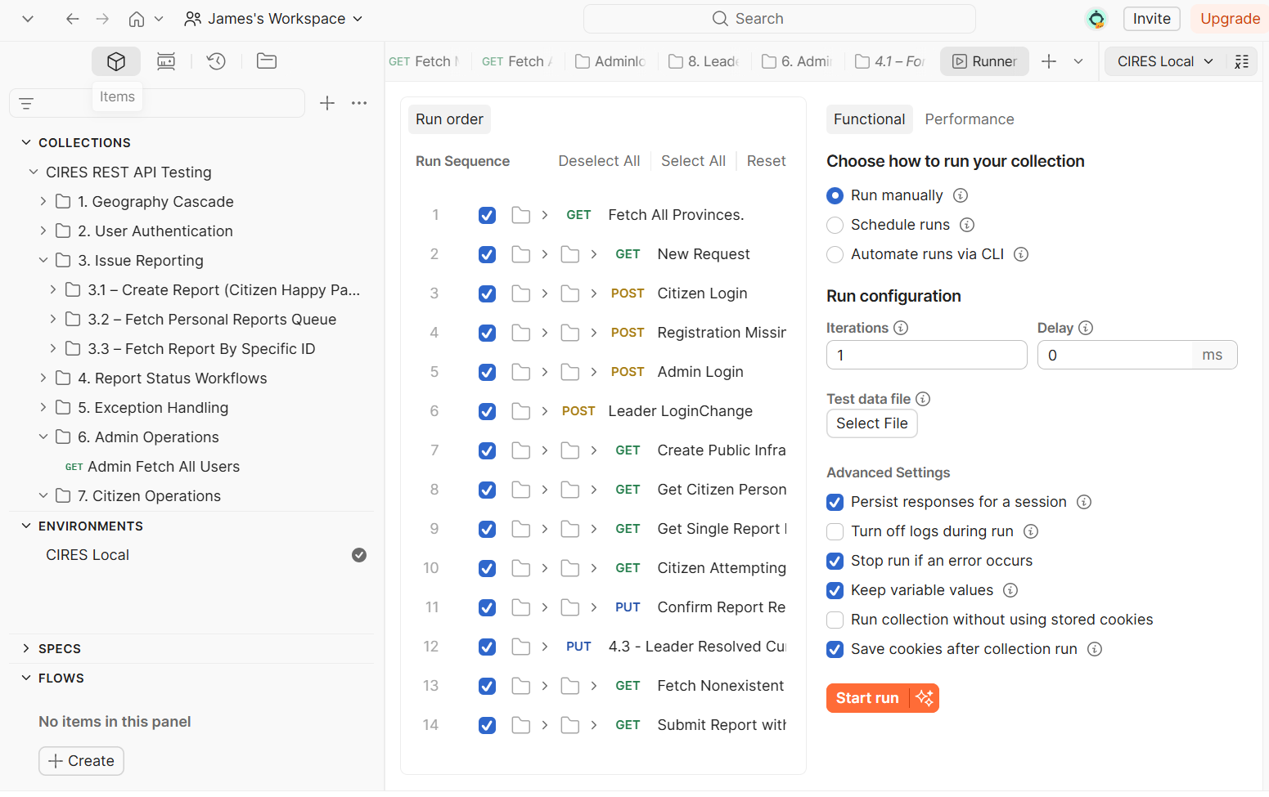

2. API Testing & Error Handling
- API Validation: A Postman collection was utilized to strictly test all /api/ endpoints. Critical flows verified included user authentication, geographic cascade population, issue submission, and the full escalation lifecycle.
- Security & Routing Resolution: Addressed critical preflight (OPTIONS) request failures between the React frontend and Spring Boot backend by implementing a HIGHEST_PRECEDENCE custom CORS filter. Resolved 403 Forbidden errors by accurately configuring the SecurityFilterChain to whitelist necessary public endpoints like /api/auth/**.
- Global Exception Handling: Implemented a centralized GlobalExceptionHandler to catch runtime errors (e.g., ResourceNotFoundException) and return standardized, clean JSON error responses, preventing the exposure of internal stack traces to the client.

3. End-to-End Workflow Validation
The core supply chain pipeline was tested by simulating a full lifecycle:
- Citizen Submission: Logging in as CITIZEN to register and submit a report (Initial Status: PENDING).
- Officer Review: Logging in as LOCAL_OFFICER to review and update the status to IN_PROGRESS.
- Breach Simulation: Simulating an SLA breach to trigger automatic escalation to the next administrative level.
- Supervisory Override: Logging in as SUPERVISOR to view the escalated case and perform a Resolution Override.
- Final Verification: Returning as CITIZEN to verify the updated status and submit quality feedback.

4.Verified Test Flows
- Cascading Logic: Citizen logs in $\rightarrow$ completes cascading address $\rightarrow$ submits report $\rightarrow$ verifies appearance in "My Reports."
- Queue Management: Leader logs in $\rightarrow$ sees Citizen's report in queue $\rightarrow$ changes status to IN_PROGRESS.
- Real-time Updates: Citizen refreshes dashboard $\rightarrow$ sees updated status $\rightarrow$ Timeline updates.
- Admin Utilities: Admin searches for Citizen by National ID $\rightarrow$ promotes Citizen to Leader.
- Session Security: Verified that expired JWTs seamlessly redirect users to the login screen.
Deployment & Finalization

1. Deployment Architecture
The CIRES platform is designed for cloud deployment with a decoupled, containerized architecture:
- Backend: A Spring Boot 3 application packaged via Docker, deployed to the Render cloud platform.
- Frontend: The React (Vite) application built into static assets and served via a dedicated cloud CDN.
- Database: A managed MySQL instance providing production-grade reliability, automated backups, and secure credential management.

2. Final Architecture Summary
- Presentation Layer (Frontend): Developed as a Single Page Application (SPA) using React. It utilizes Axios for asynchronous REST API communication, ensuring a responsive user experience without page reloads.
- Application Logic Layer (Backend): Built on Java using the Spring Boot 3 framework. It follows a strict MVC design pattern, exposing a RESTful API structure under the /api/ routing prefix.
- Data Persistence Layer: Managed by a relational database interacted with via Spring Data JPA and Hibernate, ensuring transactional integrity for all records.
- Infrastructure: The platform is containerized and deployed to cloud hosting, with sensitive database credentials and API secrets dynamically injected via environment variables.

3. Key System Improvements
- Automated Credential Provisioning: The administrative user creation flow was refactored to eliminate manual password entry, utilizing BCryptPasswordEncoder for secure storage.
- Self-Service Account Recovery: A "Forgot Password" OTP (One-Time Password) module was integrated, utilizing temporary, database-backed 6-digit numeric tokens with strict TTL (Time-To-Live) expirations.
- Geographic Data Seeding: The entire 14,000+ location dataset (Province $\rightarrow$ Village) is automatically seeded on application startup via an intelligent DataSeeder, eliminating manual geographic configuration.

Conclusion
The Citizen Issues Reporting and Escalation System (CIRES) was developed to address the challenges associated with reporting, monitoring, and resolving citizen concerns in an efficient and transparent manner. The system provides a centralized platform through which citizens can submit complaints, feedback, and service requests while enabling responsible authorities to track, manage, and resolve reported issues effectively (Elugbaju et al., 2024; Ghosh, 2024).
By incorporating an automated escalation mechanism, CIRES ensures that unresolved cases are promptly forwarded to higher authorities for intervention, reducing delays and improving accountability. The system enhances communication between citizens and service providers, promotes transparency in public service delivery, and supports informed decision-making through accurate reporting and monitoring features. Overall, CIRES contributes to improved governance, increased citizen participation, and greater public trust in institutions (Nurdiani et al., 2025; Zhang, 2023).

Recommendations
- Implement Mobile Accessibility: Develop a mobile application to enable citizens to report issues conveniently using smartphones (Patch et al., 2015; Pereira et al., 2024).
- Integrate Notification Services: Incorporate SMS and email notifications to keep citizens informed about the status and progress of their reported issues.
- Enhance Security Measures: Strengthen data protection through advanced authentication methods, encryption, and regular security audits.
- Provide User Training and Awareness: Conduct public awareness campaigns and training sessions to encourage citizens and institutions to effectively utilize the system.
- Integrate Geographic Information Systems (GIS): Include location-based reporting features to improve issue identification and response coordination.
- Support Multilingual Access: Enable the system to support multiple languages to accommodate diverse user groups.
- Generate Advanced Analytics: Incorporate dashboards and reporting tools to help decision-makers identify trends, monitor performance, and allocate resources effectively.
- Continuous System Maintenance: Regularly update and maintain the system to improve functionality, address emerging needs, and ensure reliable performance.

References
- Bélanger, F., & Carter, L. (2008). Trust and risk in e-government adoption. The Journal of Strategic Information Systems, 17(2), 165–176.
- Carter, L., & Bélanger, F. (2005). The utilization of e-government services: citizen trust, innovation and acceptance factors. Information Systems Journal, 15(1), 5–25.
- Heeks, R. (2003). Most e-Government-for-Development Projects Fail: How Can Risks be Reduced? iGovernment Working Paper Series, Paper No. 14.
- Kshetri, N. (2018). Blockchain's roles in strengthening cybersecurity and protecting privacy. Telecommunications Policy.
- Linders, D. (2012). From e-government to we-government: Defining a typology for citizen coproduction in the age of social media. Government Information Quarterly, 29(4), 446–454.
- MINECOFIN Rwanda. (2020). National Digital Transformation Policy. Republic of Rwanda.
- World Bank. (2019). Digital agriculture and rural development.

